1:

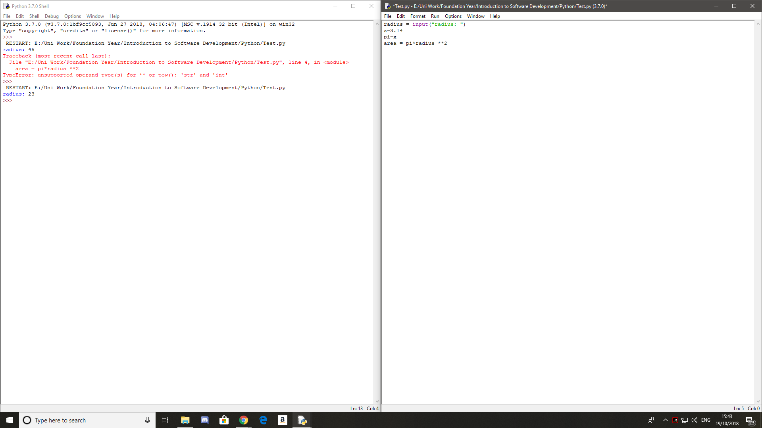

The issue with the code here is that when any input is puit into python it is automatically converted into a String not an Int.

2:



The problem with the code here is that there is no operator betweeen the the number and the brackets so the computer is unsure of what is needed to be done.

3:

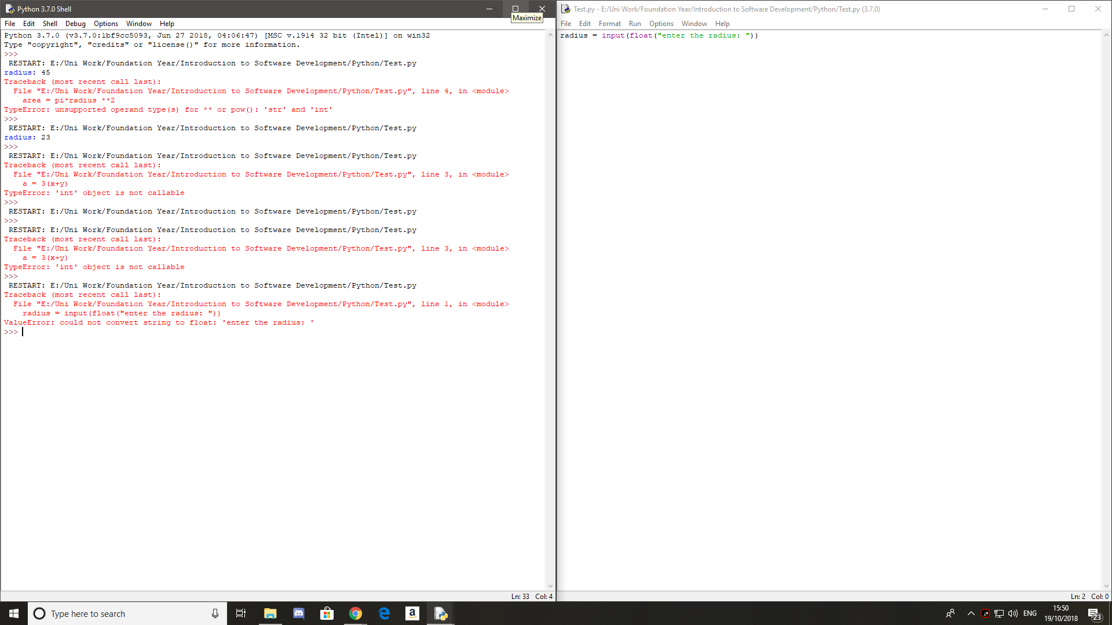

The issue with this code is that the float operation should come before the input.

4:

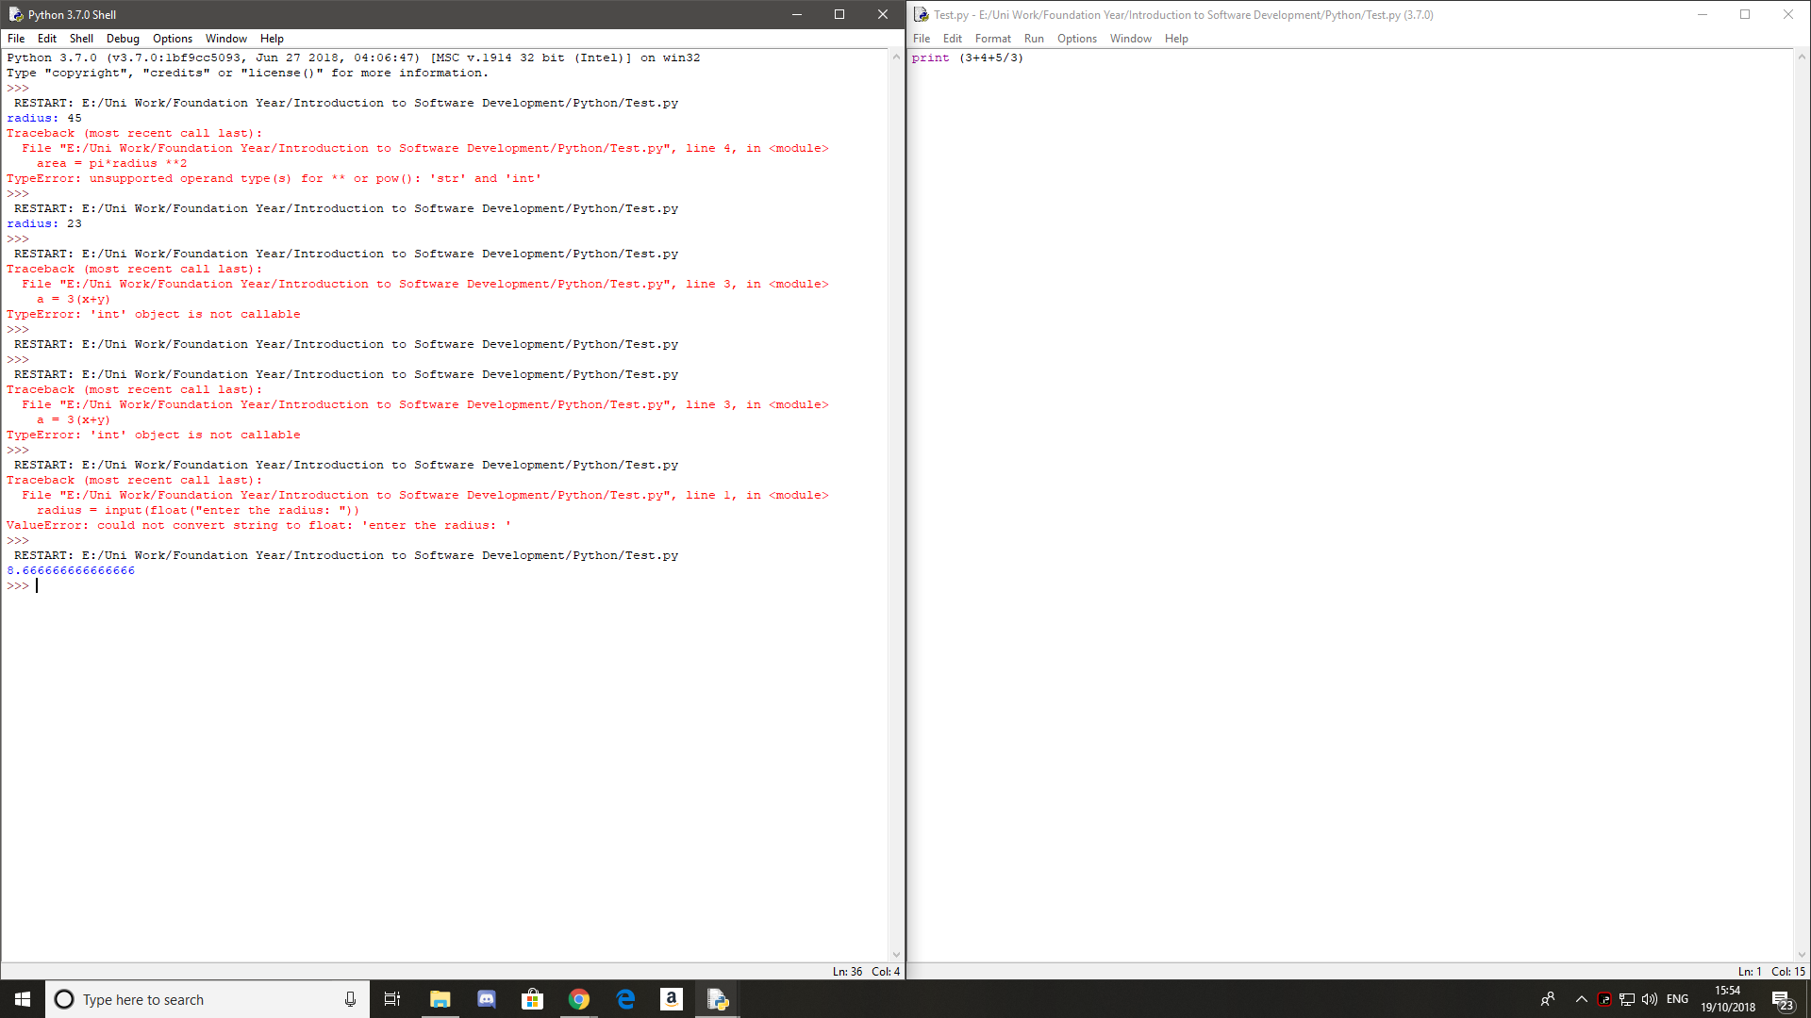

The reason that this codes does not calculate the average is that the maths is done not in order of left to right but in BODMAS order.

5:

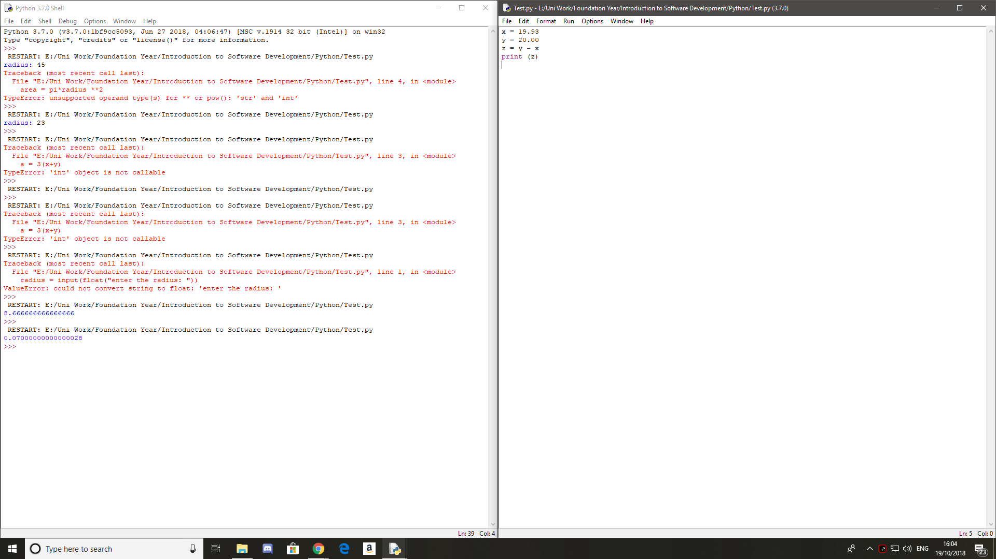

The reason that there are extra numbers at the end is because python uses floating IEEE 754 doubles.

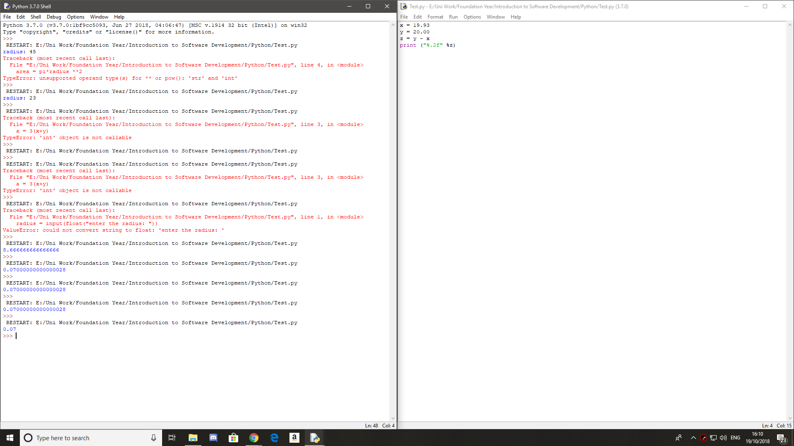

6:

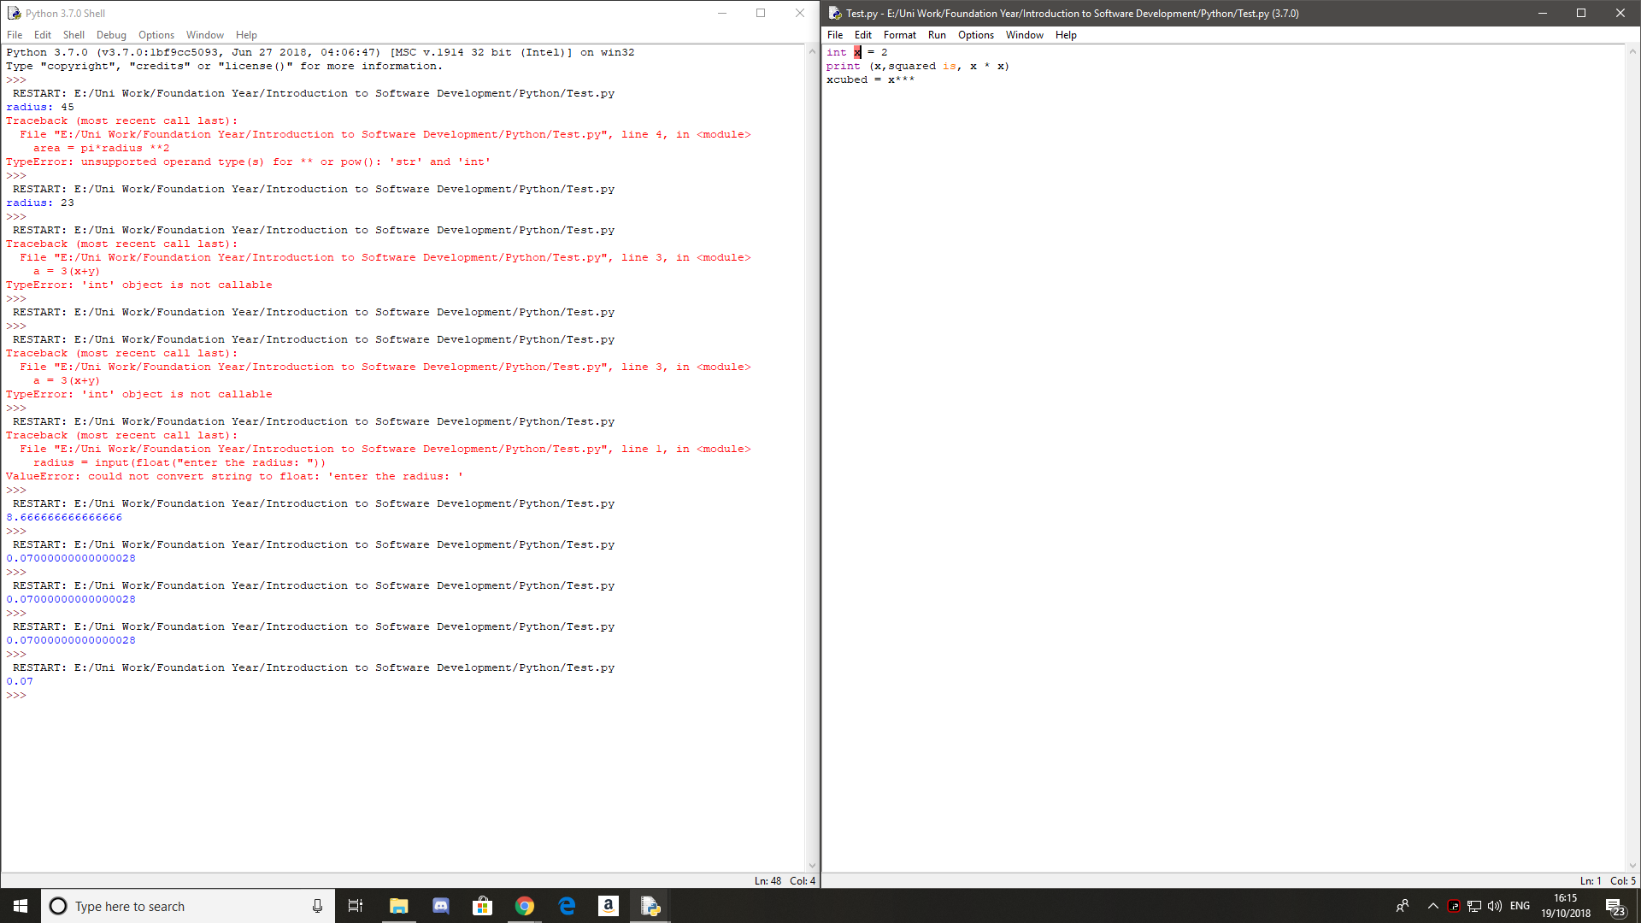

The first line of code for this program does not require an int, the second line for this code needed speech marks for all the elements on the line. Lastly, on the last line only 2 \*s are required.

7:

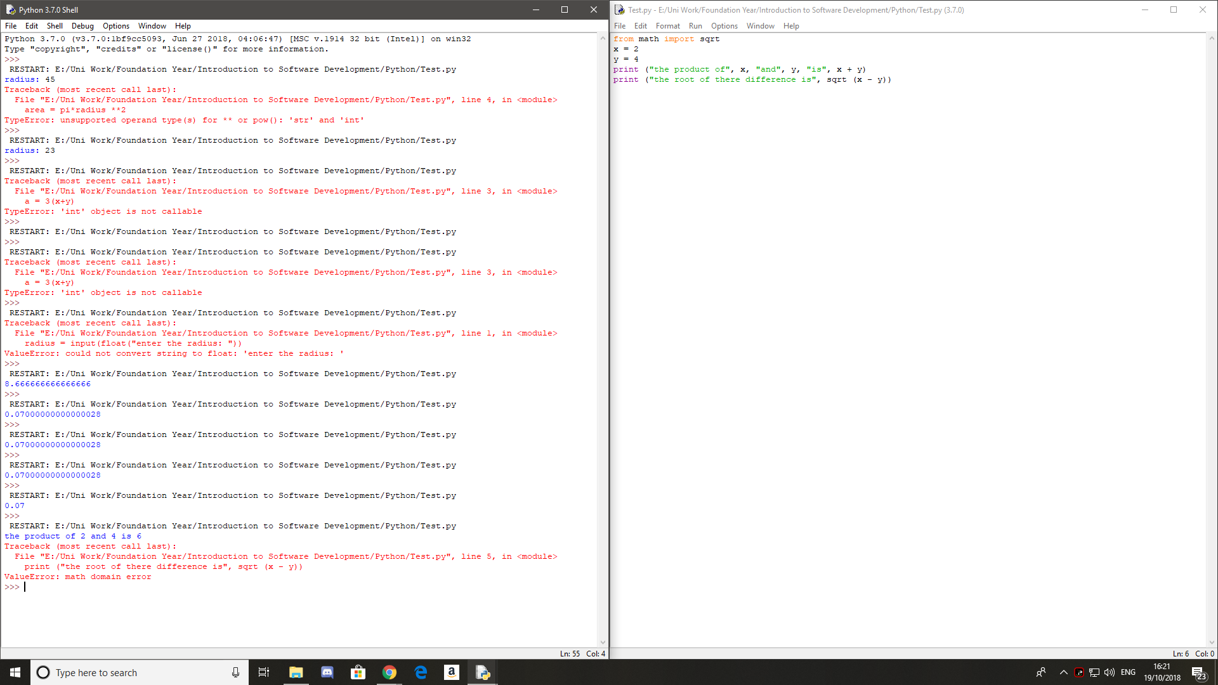

The first error is with the first print where the sum is being calculated not the product. The second error is on the last line is where were trying to calculate the square root of a negative number.

8:

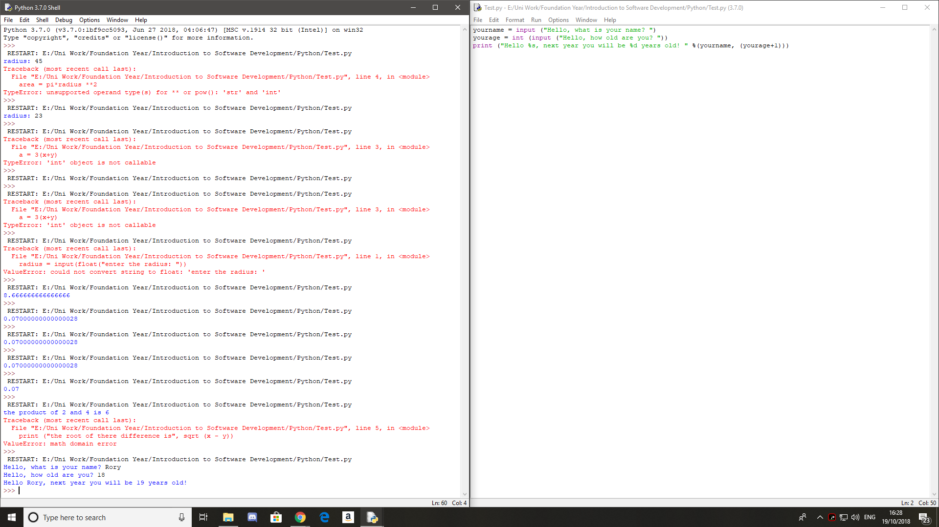

9;

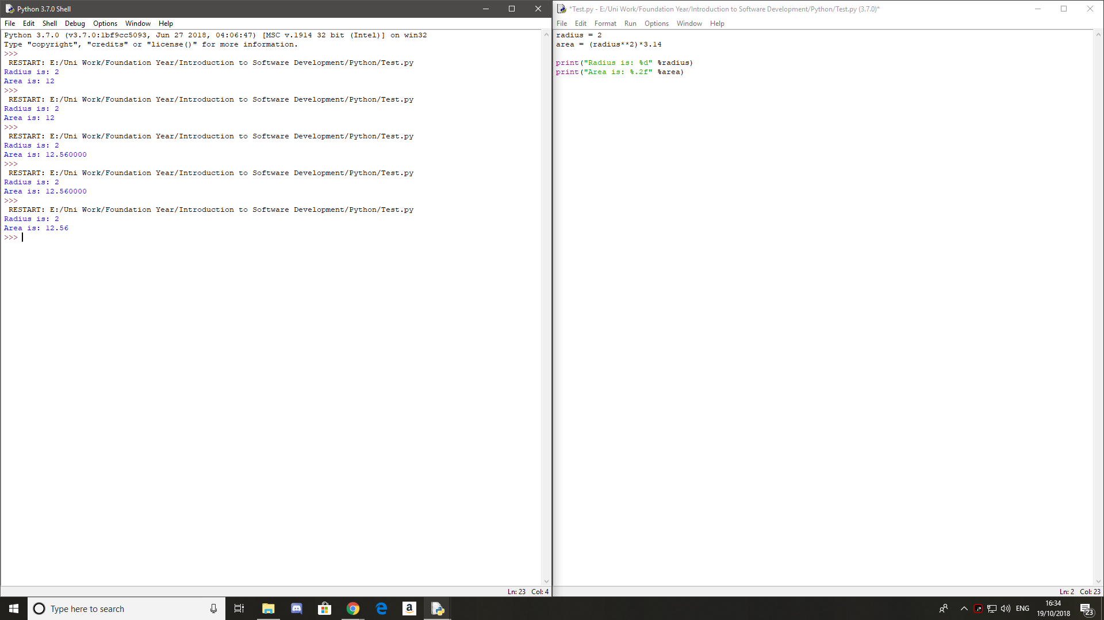

10:

